MAWLANA BHASHANI SCIENCE AND TECHNOLOGY UNIVERSITY
SANTOSH, TANGAIL-1902



DEPARTMENT OF INFORMATION AND COMMUNICATION TECHNOLOGY
Lab Report

Lab Report No : 05
Lab Report on : Development and Deployment of a Responsive Personal Portfolio Using
HTML and Bootstrap 5
Course Title : Web Application Development Lab
Course Code : ICT-3204
Submitted By | Submitted To
Name: Kuldip Saha Mugdha  ID: IT-22018  3rd Year, 2nd Semester  Session: 2021-2022  Dept. of ICT, MBSTU | Mr. Md. Anowar Kabir  Lecturer  DEPARTMENT OF INFORMATION AND COMMUNICATION TECHNOLOGY  MAWLANA BHASHANI SCIENCE AND TECHNOLOGY UNIVERSITY

Date of Performance: 9/12/25 Date of Submission: 15/12/25
Introduction:
In the digital era, having an online presence is essential for personal and professional growth. This lab report documents the process of designing and publishing a personal portfolio. Through this project, I explored web design basics, content organization, and digital presentation—all without the need for advanced coding skills.

Objectives:
The objective of this lab experiment is to design, develop, and deploy a responsive personal portfolio website using modern web development technologies. The website demonstrates the use of HTML5, Bootstrap 5, Google Fonts, AOS (Animate On Scroll) animations, and other supporting technologies to create a visually appealing, responsive, and user-friendly portfolio suitable for professional use.

Tools and Technologies Used
- HTML5 – For structuring the web content
- CSS3 – For additional styling and layout customization
- Bootstrap 5 – For responsive design and pre-built UI components
- Google Fonts – For enhanced typography
- AOS (Animate On Scroll) Library – For scroll-based animations
- JavaScript – For interactive features and animations
- VS Code – Code editor used for development
- Web Browser – Google Chrome for testing and debugging

Development Environment:
- Code editor: VS Code
- Browser: Chrome / Firefox / Edge (latest)
- Git installed locally

Working Principle:
The working principles of the responsive website are based on the following core ideas:
Bootstrap Responsive Grid
A 12-column grid adjusts layout automatically on mobile, tablet, and desktop using breakpoints.
Mobile-First Design
Design starts from small screens and scales upward for better performance and usability.
Google Fonts Integration
Fonts load from Google’s CDN, ensuring consistent typography and faster rendering.
AOS (Animate On Scroll)
Elements animate when they enter the viewport using data-aos attributes and AOS JavaScript.
Bootstrap Components
Interactive components like navbar toggler work using Bootstrap’s JavaScript bundle.
GitHub Pages Hosting
GitHub Pages directly serves static files (HTML, CSS, JS) from the repository’s main branch as a website.
Project Structure:
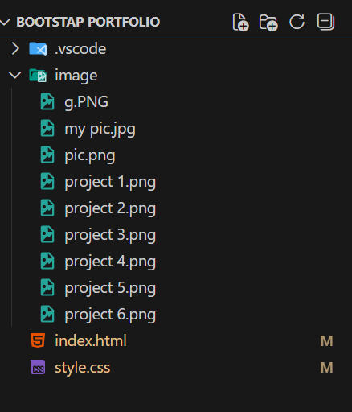
Important Implementation Notes:
HTML <head> (essential tags and CDN links):
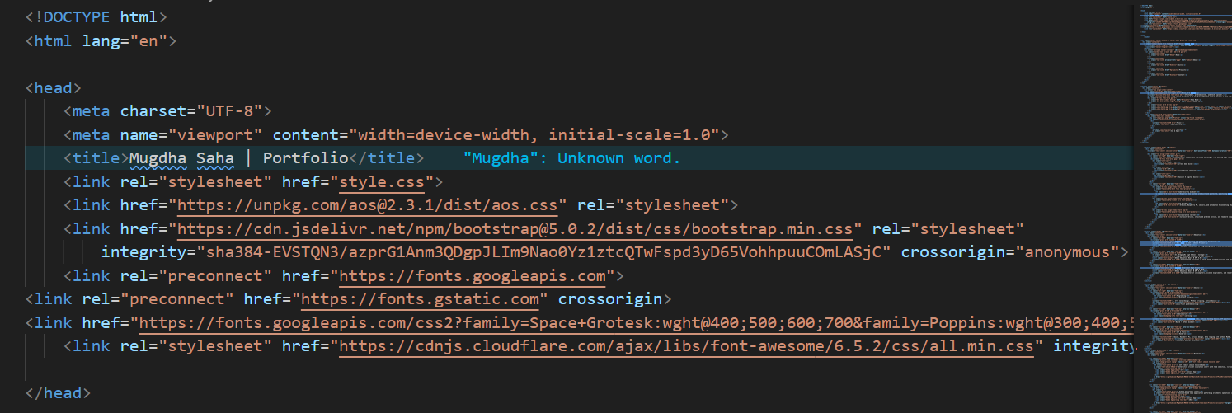

Example Responsive Navbar (Bootstrap):
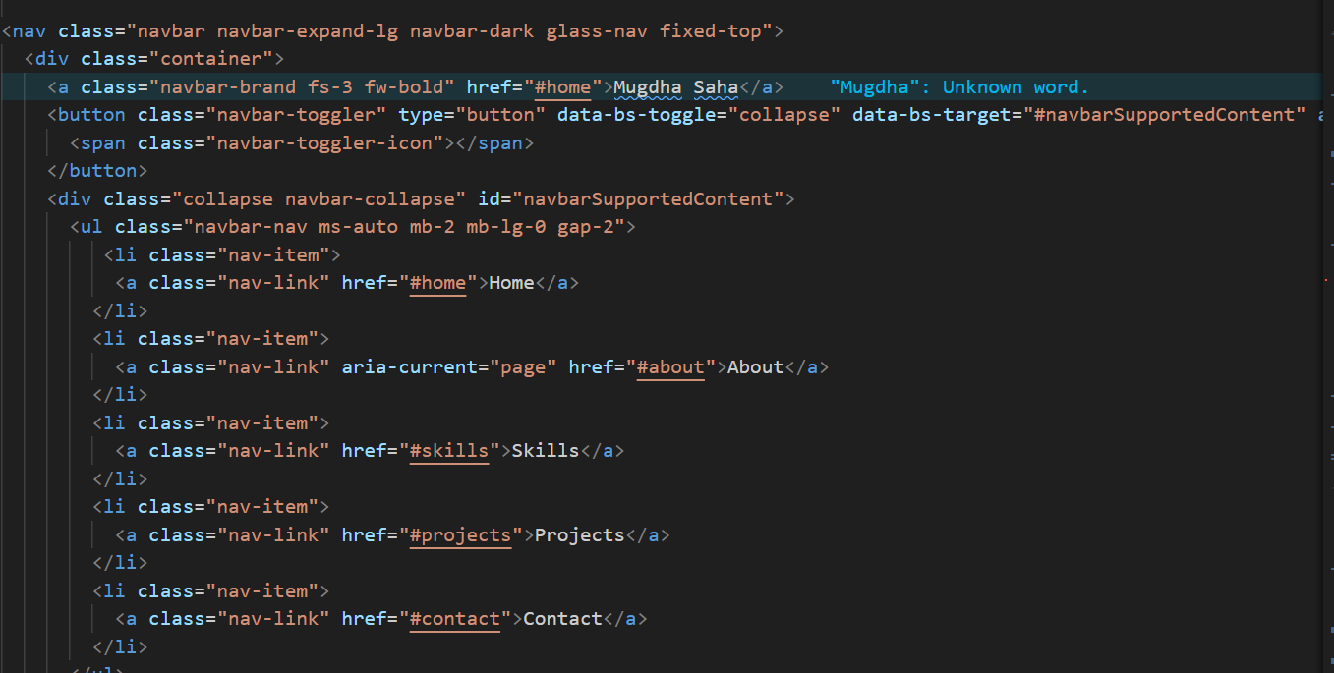

1. Creating the Navigation Bar :
Organized the site using a navigation bar with the following sections:
Home, About, Skills, Projects, Contact.

2. Developing the “Home” Section:
In this section, I introduced myself, described my academic background, and highlighted my technical skills.
Code:
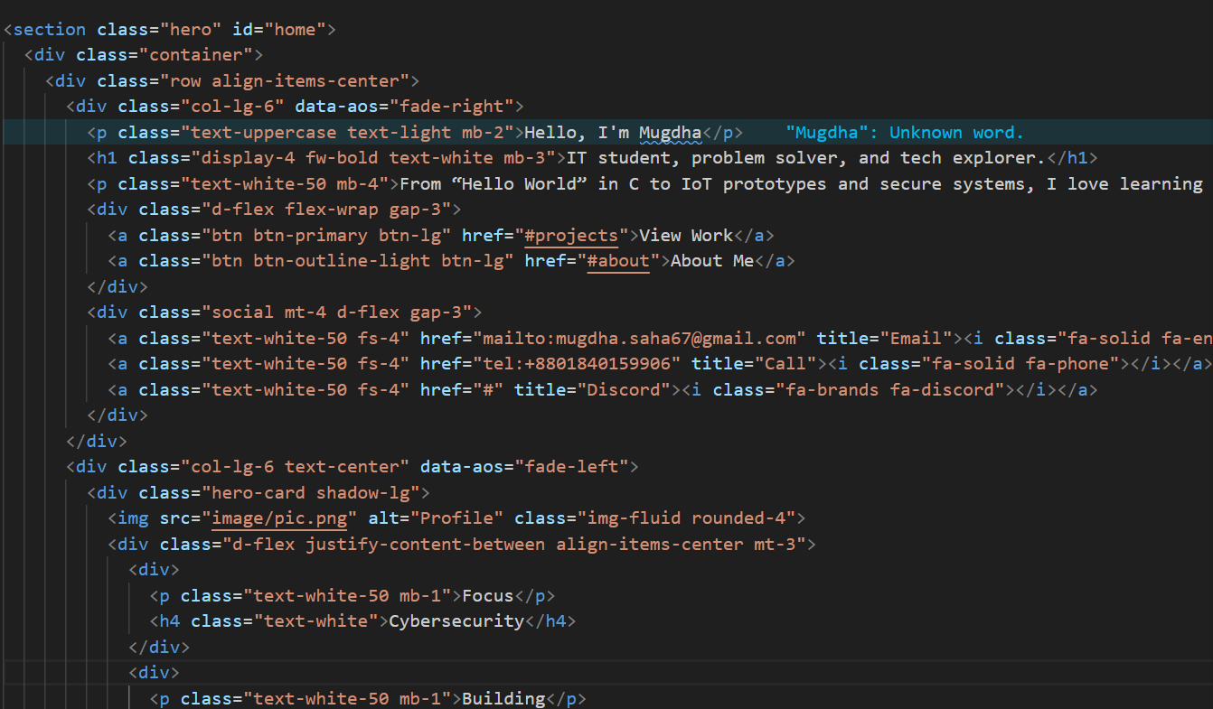
➢ Visual Overview of the “Home” Section:
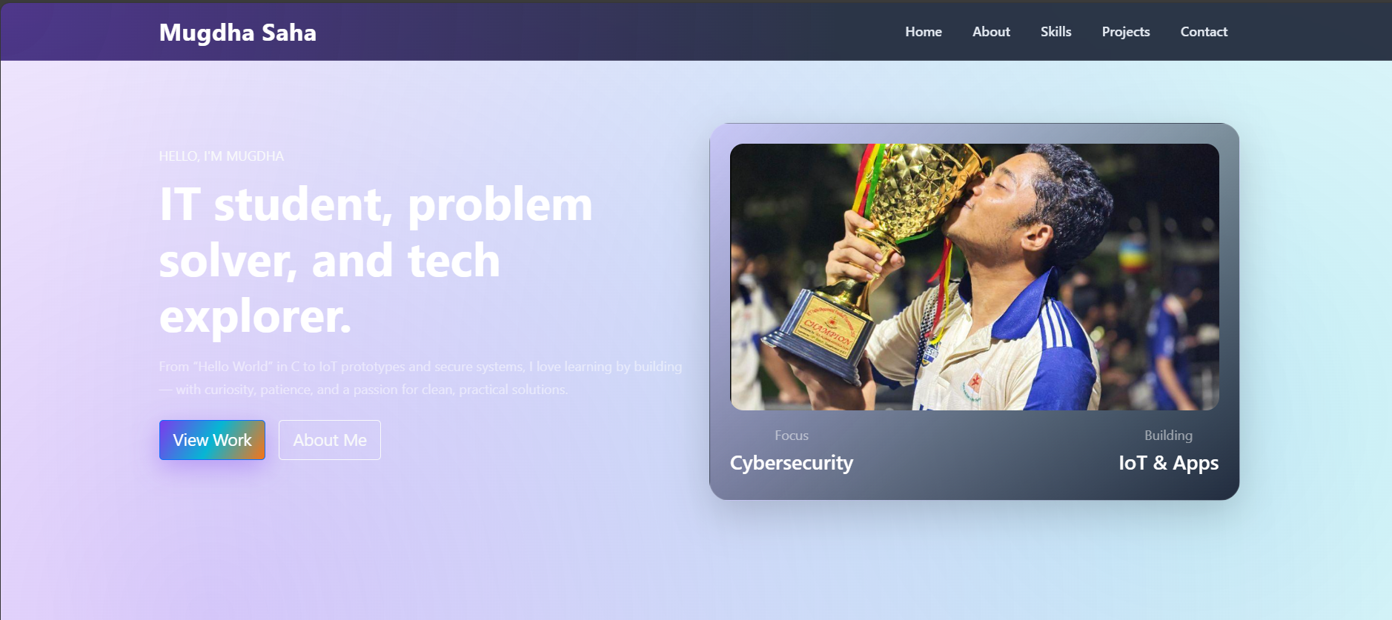
Fig 01: Home Section
2. Developing the “About” Section:
Code: 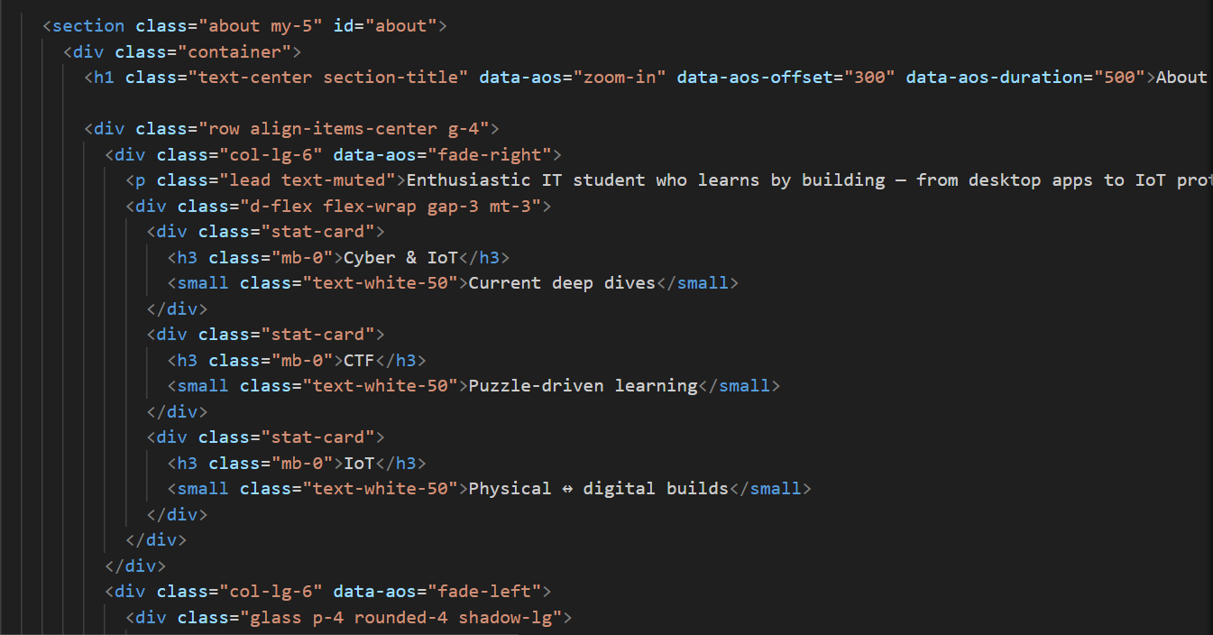

➢ Visual Overview of the “About” Section:
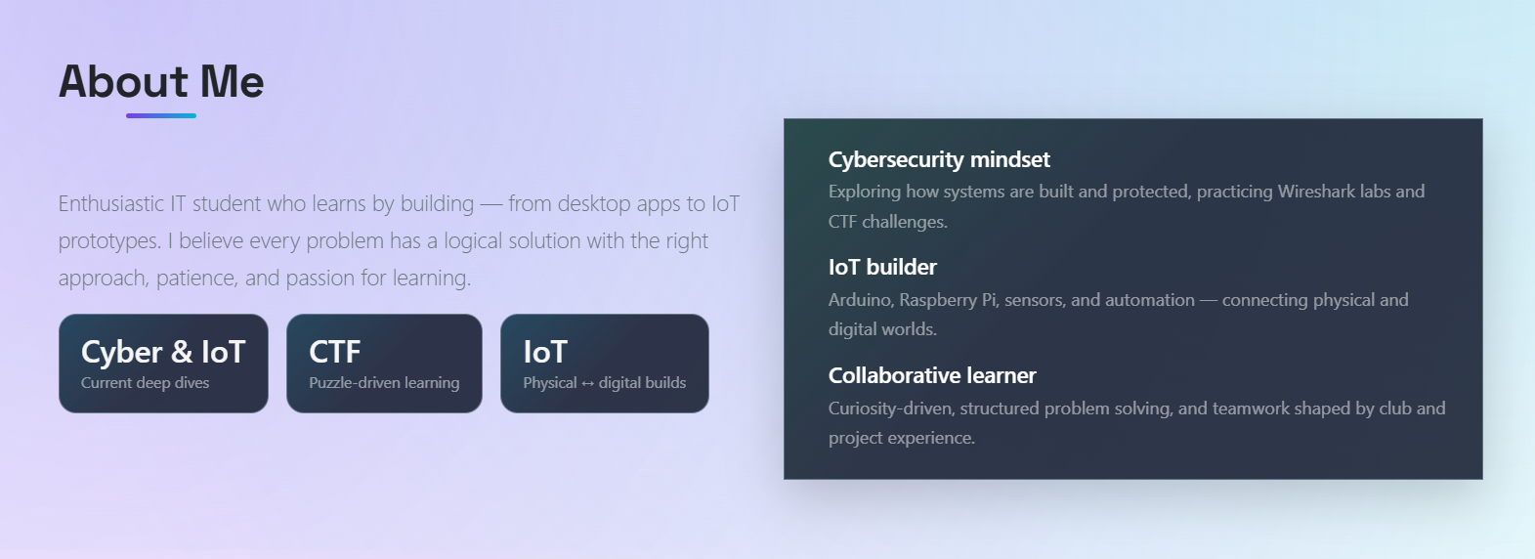
Fig 02: About Me Section

3. Developing the “Education” Section:
Code:

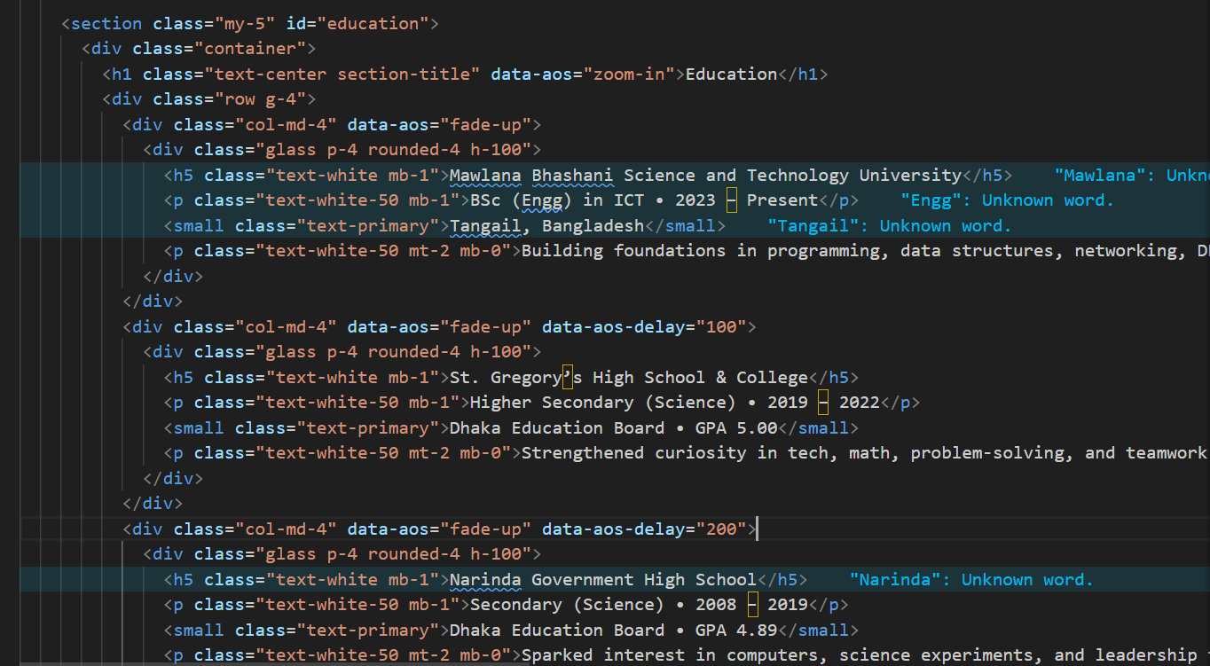

➢ Visual Overview of the “Education” Section:


Fig 03: Education Section

4. Developing the “Skills” Section:
Code:

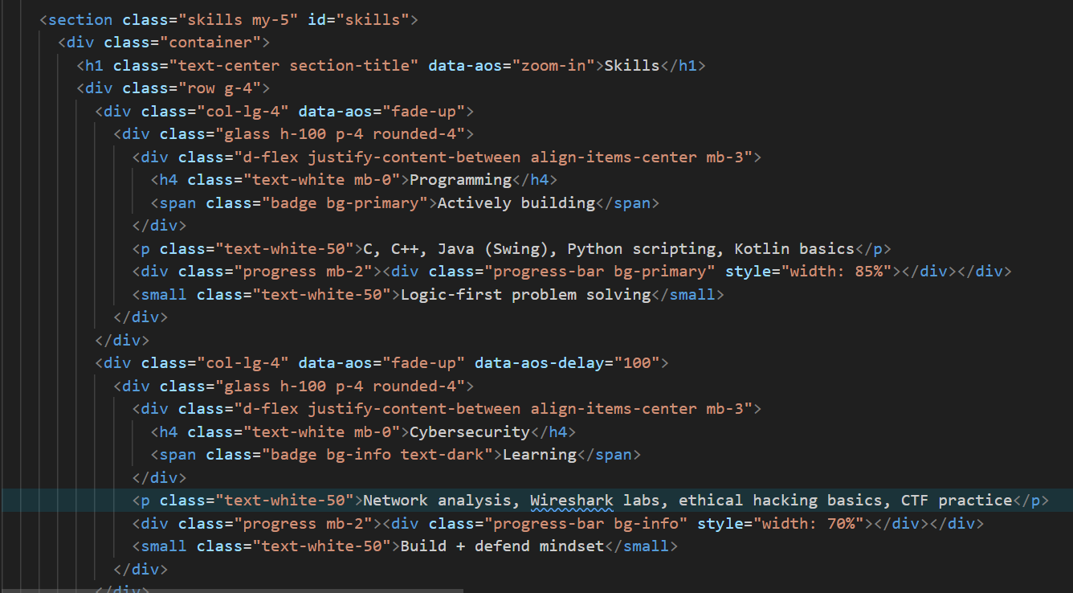

➢ Visual Overview of the “Skills” Section:

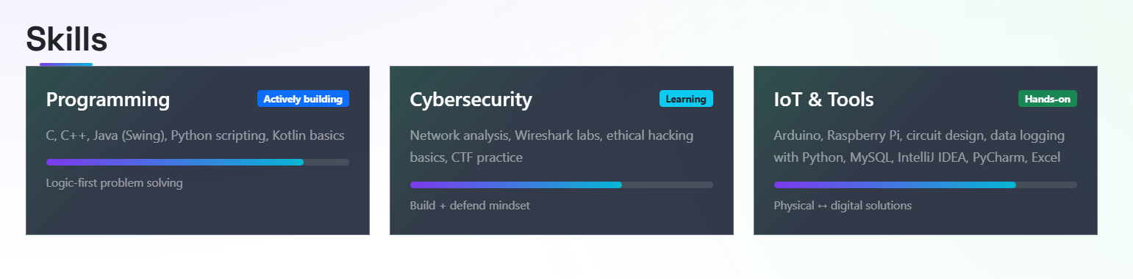
Fig 04: Skills Sections

5. Developing the “Projects” Section:
Code:
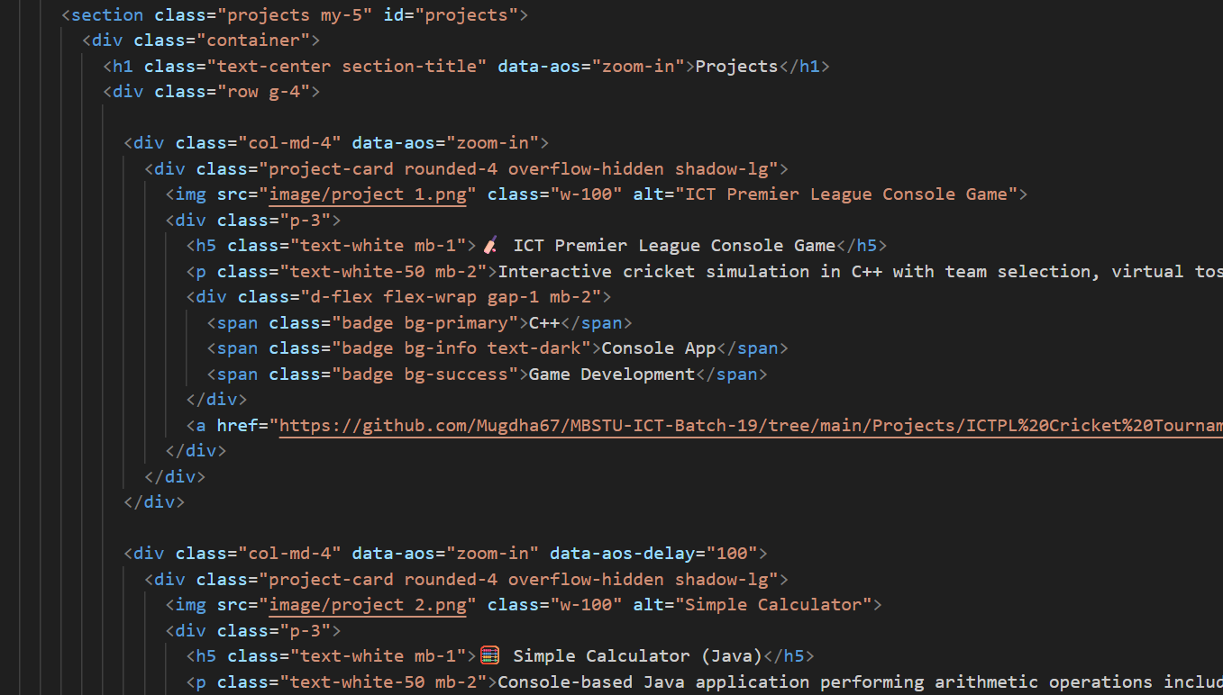

➢ Visual Overview of the “Projects” Section:
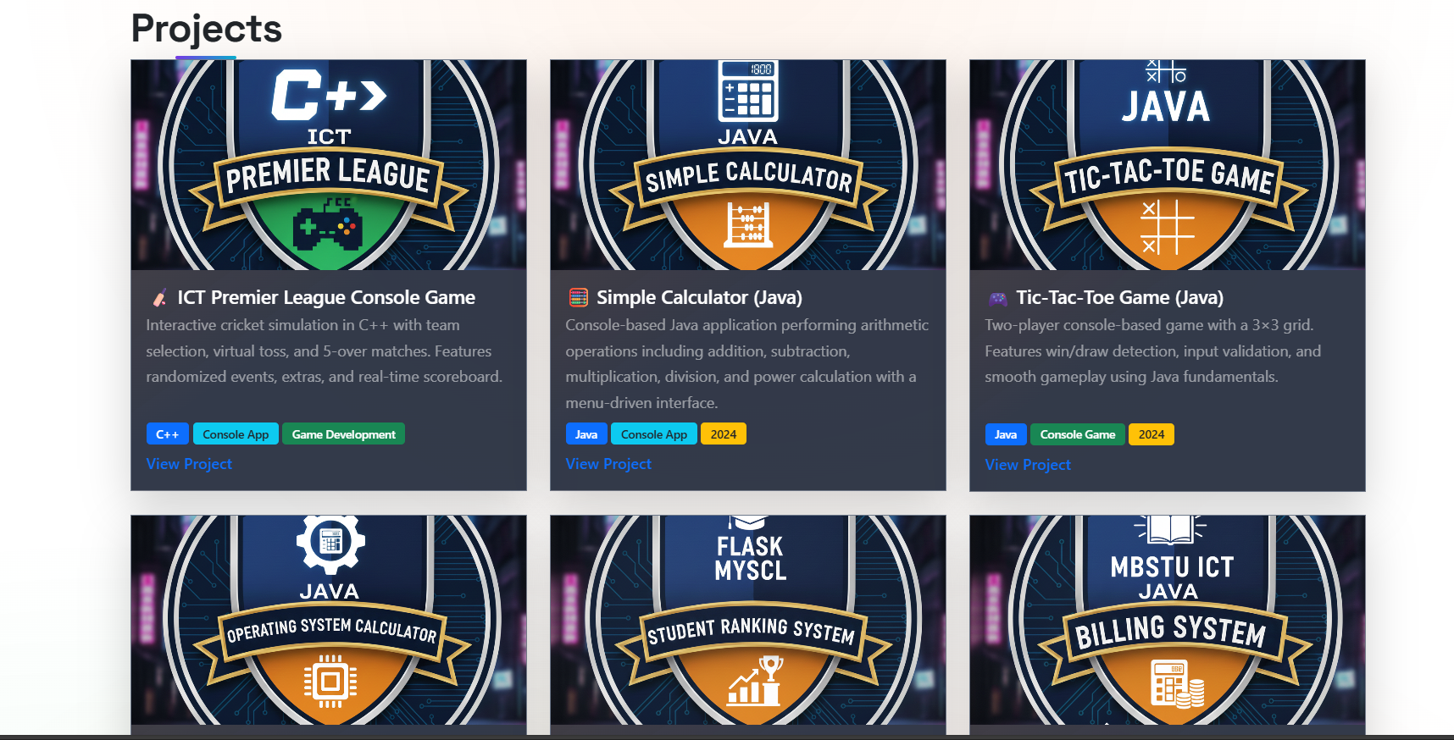
Fig 05: Projects Section
7. Developing the “Contact” Section:
Code:
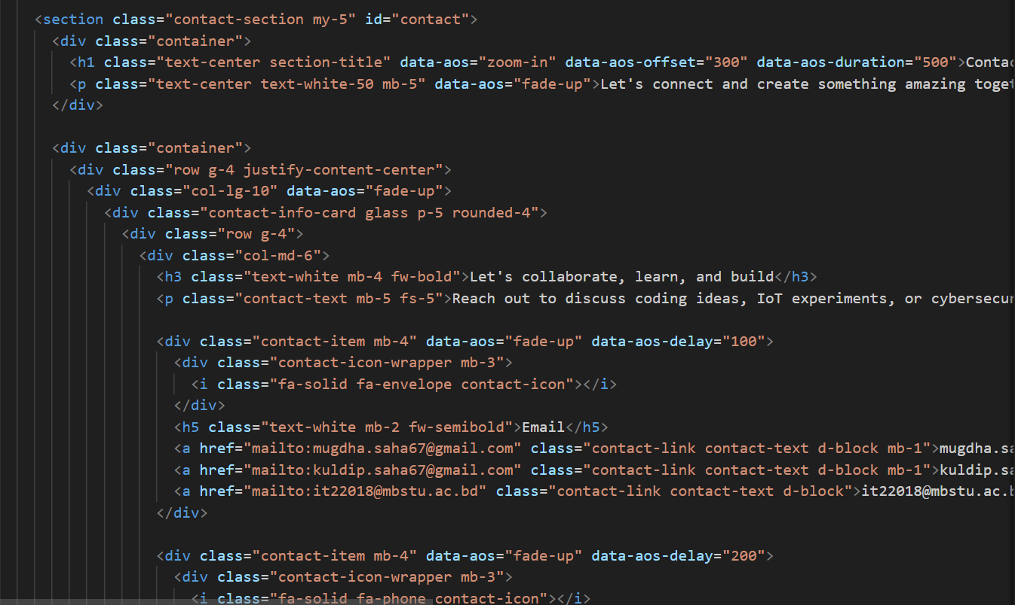
➢ Visual Overview of the “Contact” Section:
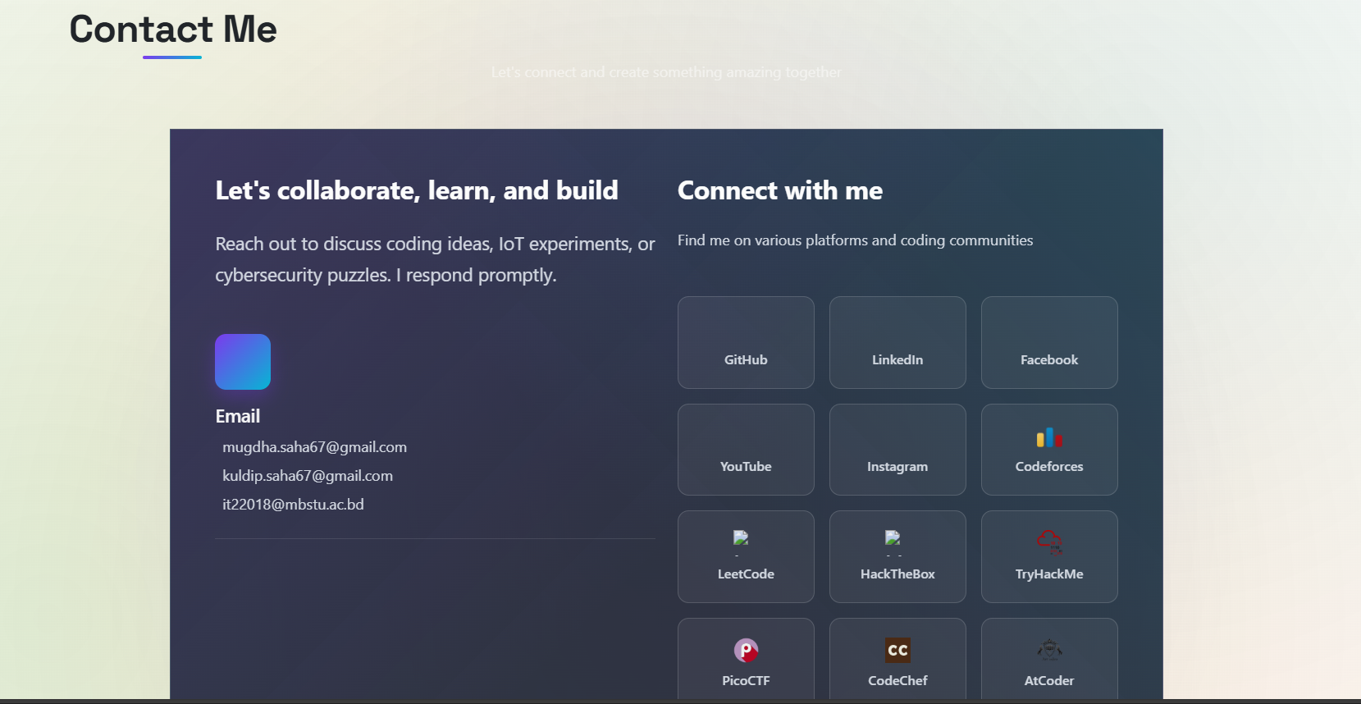Fig 06: Contact Section
Live link of GitHub: Mugdha Saha | Portfolio
Conclusion:
This lab successfully demonstrated the development and deployment of a responsive personal portfolio website using HTML5 and Bootstrap 5. The integration of Google Fonts and AOS animations enhanced the visual appeal and interactivity of the website. The experiment helped in understanding responsive web design principles and the effective use of modern front-end frameworks.

